Progression in Calculations
+ = signs and missing numbers  Children need to understand the concept of equality before using the ‘=’ sign. Calculations should be written either side of the equality sign so that the sign is not just interpreted as ‘the answer’.  2 = 1+ 1  2 + 3 = 4 + 1  Missing numbers need to be placed in all possible places.  3 + 4 = = 3 + 4  3 + = 7 7 = + 4  Counting and Combining sets of Objects  Combining two sets of objects (aggregation) which will progress onto adding on to a set (augmentation)  Understanding of counting on with a numbertrack  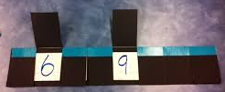  Understanding of counting on with a numberline  Regrouping to make 10  Adding three single digits  Adding 9 or 11 by adding 10 and adjusting by 1 Counting on in 10’s and 1’s  e.g. Add 9 by adding 10 and adjusting by 1 23 + 12 = 23 + 10 + 2  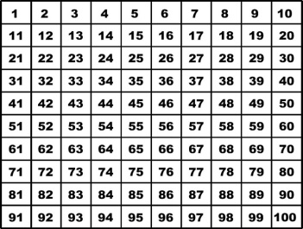  = 33 + 2  = 35  35 + 9 = 44  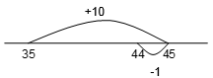  Column method – no regrouping  Column Method – regrouping | FS  Year 1  FS  Year 1  Year 1  Year 1  Year 2  Year 1  Year 2  Year 1  Year 2  Year 2  Year 3  Year 2  Year 3  Year 4  Year 5  Year 6
  CONCRETE | PICTORAL | ABSTRACT
  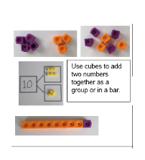 | 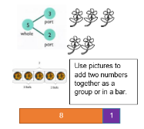 | 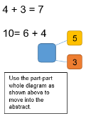
  CONCRETE | PICTORAL | ABSTRACT
  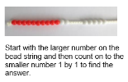 | 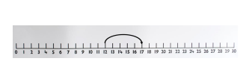  12 + 5 = 17 | 5 + 12 = 17  Place the larger number in your head and count on, (using fingers) the smaller number to find your answer.
  CONCRETE | PICTORAL | ABSTRACT
  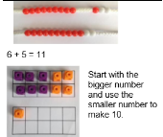 | 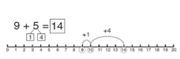 | 7 + 4 = 11  If I am seven how many more do I need to make ten?  How many more do I need to add on now?
  CONCRETE | PICTORAL | ABSTRACT
  4 + 7 + 6 = 17  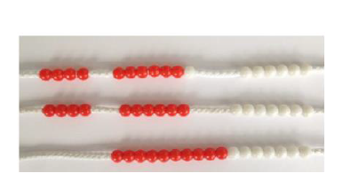  Following on from making 10, make 10 with 2 of the digits (if possible) then add on the third digit. | 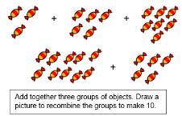 | 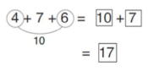  Combine the two numbers that make 10 and then add on the remainder.
  CONCRETE | PICTORAL | ABSTRACT
  24 + 15 =  Add together the ones first then add the tens. Using base 10 blocks, moving onto place value counters.  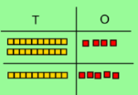  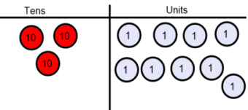 | After practically using base 10 blocks and place value counters, children can draw the counters to help them solve additions. | Calculations:-  21 + 42 =
    T | U
    20 + 1  40 + 2  60 + 3 | 21  + 42  63
  CONCRETE | PICTORAL | ABSTRACT
  Make both numbers on a place value grid.  Add up the units and exchange 10 ones for one 10.  Add up the rest of the columns, exchanging the 10 counters from one column for the next place value column until every column has been added.  This can also be done with Base 10 to help children clearly see that 10 ones equal 1 ten and 10 tens equal 100.  As children move on to decimals, money and decimal place value counters can be used to support learning. | Children can draw a pictoral representation of the columns and place value counters to further support their learning and understanding. | Start by partitioning the numbers before moving on to clearly show the exchange below the addition.  536  + 85  621  1 1  As the children move on, introduce decimals with the same number of decimal places and different. Money can be used here.  