Progression in Calculations
Physically taking away and removing objects from a whole  Counting back  Find the difference  Part Part Whole model  Make 10  Column methods without regrouping  Column method with regrouping  Fluency variation, different ways to ask children to solve 391-186: | FS  Year 1  Year 2  Year 3  Year 4  Year 1  Year 2  (Year ¾)  Year 1  Year 2  Year 2  Year 2  Year 3  Year 4  Yr4 - 6
  CONCRETE | PICTORAL | ABSTRACT
  Using physical objects, counters, cubes etc to show how objects can be taken away.  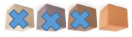  Physically taking away and removing objects from a whole (use various objects too) rather than crossing out, children will physically remove the objects.  4 – 3 = 1  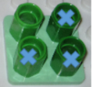 | Children to draw the concrete resources they are using and cross out.  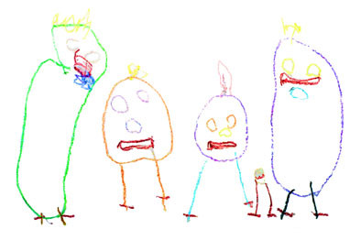  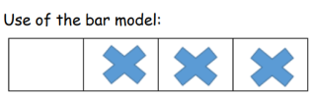 | 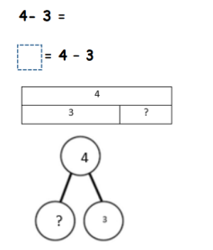
  CONCRETE | PICTORAL | ABSTRACT
  Make the larger number in your subtraction. Move the beads along your bead string as you count backwards in ones.    13 – 4    Use counters and move  them away from the  group as you take them  away, counting  backwards as you go. | count back on a number line or number track (also using empty numberlines).  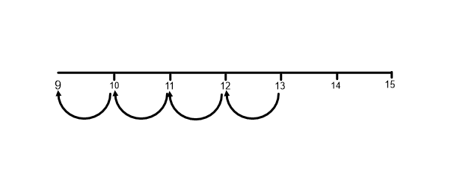  Children to represent what they see pictorially e.g.  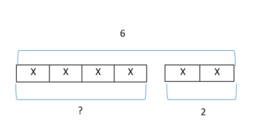  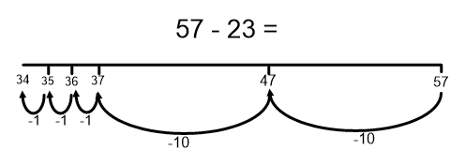  Progress all the way to counting back using two 2-digit numbers. | Put 13 in your head, count back 4. What number are you at? Use your fingers to help.  Counting back in head any 3, 2 or 1 digit number from a 3 digit, using fluent methods.
  CONCRETE | PICTORAL | ABSTRACT
  Finding the difference (using cubes, numicon or Cuisenaire rods, 100 square and other objects can also be used)  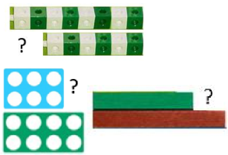 | Children to draw the cubes/other concrete objects which they have use  XXXXXXXX  XXXXXX  Use of the bar model  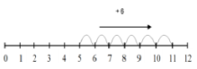  count on  to find the  difference. | Find the difference between 8 and 6.  8 – 6, the difference is ?  Children to also explore why 9 - 7 = 8 – 6 (the difference, of each digit, has changed by 1 so the difference is the same- this will help when solving 10000-9987)
  CONCRETE | PICTORAL | ABSTRACT
  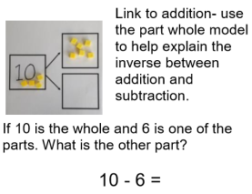 | 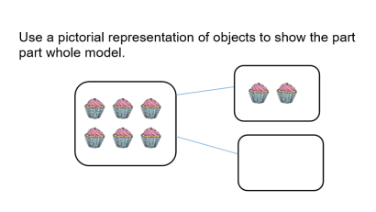 | 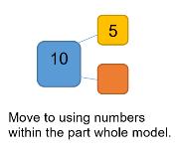
  CONCRETE | PICTORAL | ABSTRACT
  Making 10 (using numicon or ten frames)  14 – 5  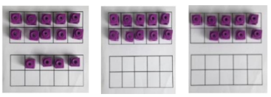  Children could also do this by subtracting a 5 from the 10.   | Children to present the ten frame pictorially  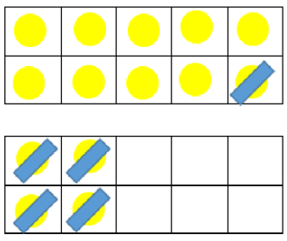 | 14 – 5 = 9 You also want children to see related facts e.g. 15 – 9 = 5  Children to represent how they have solved it e.g  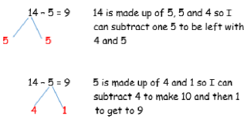
  CONCRETE | PICTORAL | ABSTRACT
  Recording addition and subtraction in expanded columns can support understanding of the quantity aspect of place value and prepare for efficient written methods with larger numbers. The numbers may be represented with Dienes apparatus. E.g. 75 – 42  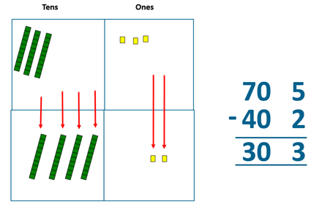  Show how you partition  numbers to subtract.  Again make the larger  number first. | Draw the Base 10 or place value counters alongside the written calculation to help to show working.  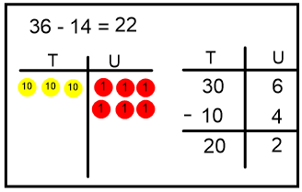  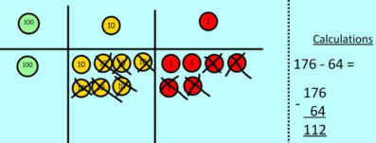 | 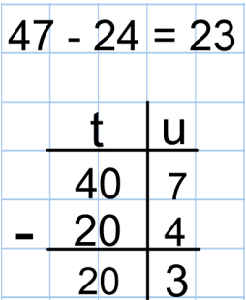 This will lead to a clear written column subtraction:-  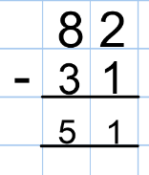
  CONCRETE | PICTORAL | ABSTRACT
  Column method (using base 10 and having to exchange) 45-26  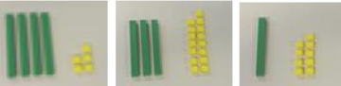 | Represent the base 10 pictorially  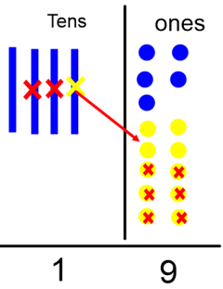 | It’s crucial that the children understand that when they have exchanged the 10 they still have 45.  45 = 30 + 15  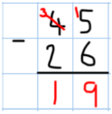
  Column method (using place value counters)  234-88  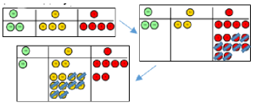 | Once the children have had practice with the concrete, they should be able to apply it to any subtraction.  Like the other pictorial representations, children to represent the counters. | 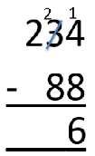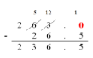
  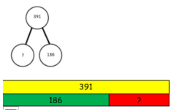 | Raj spent £391, Timmy spent £186. How much more did Raj spend?  I had 391 metres to run. After 186 I stopped. How many metres do I have left to run? | 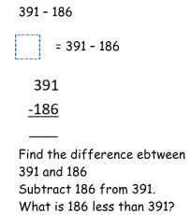 | What’s the calculation? What’s the answer? 