Progression in Calculations
Sharing objects into groups  Understand division as repeated grouping and subtracting  Division with Arrays  Division with remainders  Division using 2 digit by 1 digit  Sharing using place value counters  Bus stop method  Long Division | Year 1  Year 2  Year 2  Year 2  Year 3  Year 2  Year 3  Year 3  Year 4  Year 3  Year 4  Yr 4 – 6  Yr4-6
  CONCRETE | PICTORAL | ABSTRACT
  6 shared between 2  (other concrete objects can also be used e.g. children and hoops, teddy bears, cakes and plates)  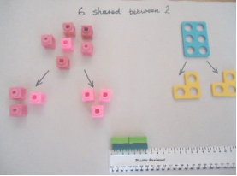 | 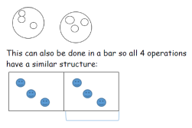 | 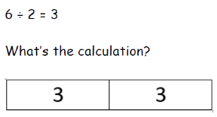
  CONCRETE | PICTORAL | ABSTRACT
   | 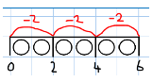 | Abstract number line  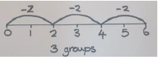
    Divide quantities into equal groups.
    Use cubes, counters, objects or place value counters to aid understanding.
    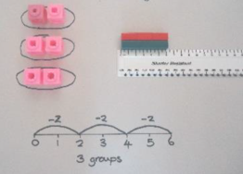
  CONCRETE | PICTORAL | ABSTRACT
   | 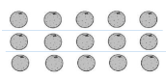 | Find the inverse of multiplication and division sentences by creating four linking number sentences.  7 x 4 = 28  4 x 7 = 28  28 ÷ 7 = 4  28 ÷ 4 = 7
    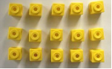
    Link division to multiplication by creating an array and thinking about the number sentences that can be created.
    e.g. 15 ÷ 3 = 5
    5 x 3 = 15
    15 ÷ 5 = 3
    3 x 5 = 15
    Draw an array and use lines to split the array into
    groups to make multiplication and division sentences.
  CONCRETE | PICTORAL | ABSTRACT
  Divide objects between groups and see how much is left over.  Use of lollipop sticks to form wholes:- 13 ÷ 4 =    Use of Cuisenaire rods and rulers (using repeated subtraction)  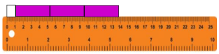 | 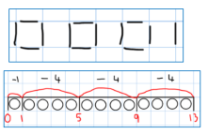 | 13 ÷ 4 = 3 remainder 1  Children to count their times table facts in their heads.  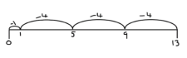
  CONCRETE | PICTORAL | ABSTRACT
  Using Base 10 (no remainders)  48 ÷ 3 = 14  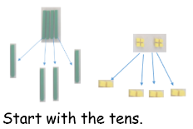 | Children to represent the base 10 and sharing pictorially. | 48 ÷ 4 =  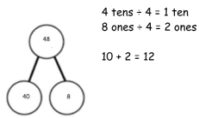
  CONCRETE | PICTORAL | ABSTRACT
  42 ÷ 3 = 14  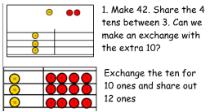 | 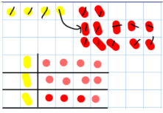 | 42 ÷ 3  42 = 30 + 12  30 ÷ 3 = 10  12 ÷ 3 = 4  10 + 4 = 14
  CONCRETE | PICTORAL | ABSTRACT
  Use of the ‘bus stop method’ using grouping and counters. Key language for grouping- how many groups of X can we make with X hundreds’- this can also be done using sharing! 615 ÷ 5  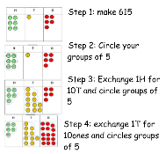 | This can easily be represented pictorially, till the children no longer to do it. It can also be done to decimal places if you have a remainder! | 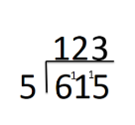
  CONCRETE | PICTORAL | ABSTRACT
  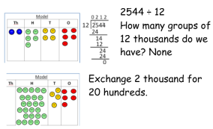  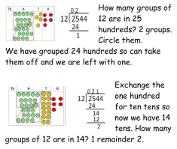  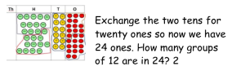 | Children to represent the counters, pictorially and record the subtractions beneath. | 