Progression in Calculations
Doubling  Repeated grouping/repeated addition  Use number lines to show repeated groups  Use arrays to illustrate commutativity  Partition to multiply  Grid Method  Column Multiplication | FS  Year 1  (Year 2)  Year 1  Year 2  Year 3  Year 2  Year 3  Year 4  Year 2  Year 3  Year 4  Year 3  Year 4  Year 4  Year 5  Year 4  Year 5  Year 6
  CONCRETE | PICTORAL | ABSTRACT
  Washing line, and other practical resources for counting. Concrete objects. Numicon; bundles of straws, bead strings  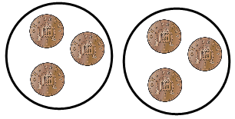  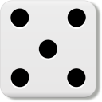 | Draw pictures to show how to double a number  Double 4 is 8  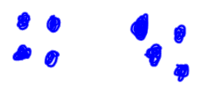  4 4 | 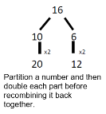
  CONCRETE | PICTORAL | ABSTRACT
  3 x 4 or 3 lots of 4  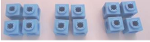  Count in multiples supported by concrete objects in equal groups. | Children to represent the practical resources in a picture e.g.  XX XX XX  XX XX XX  Use of a bar model for a more structured method  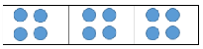 | 3 x 4  4 + 4 + 4
  CONCRETE | PICTORAL | ABSTRACT
  3 x 4  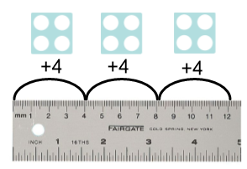 | Represent this pictorially alongside a number line e.g:  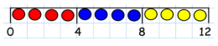 | Abstract number line  3 x 4 = 12  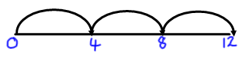
  CONCRETE | PICTORAL | ABSTRACT
  (counters and other objects can also be used) 2 x 5 = 5 x 2  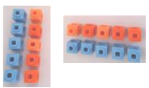  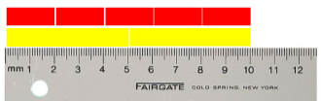 | Children to draw the arrays in different rotations, to find commutative multiplication sentences.  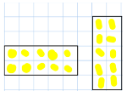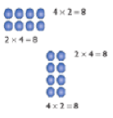  Link arrays to area of rectangles.  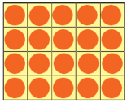 | Use an array to write multiplication sentences and reinforce repeated addition.    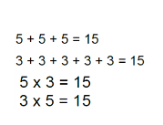
  CONCRETE | PICTORAL | ABSTRACT
  (use numicon, base 10, Cuisenaire rods)  4 x 15  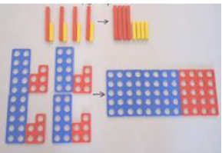 | Children to represent the concrete manipulatives in a picture e.g. base 10 can be represented like:  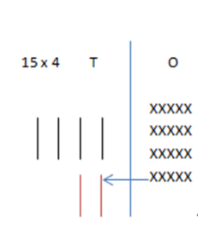 | 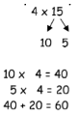  Children to be encouraged to show the steps they have taken:-  A number line can also be used:-  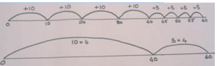
  CONCRETE | PICTORAL | ABSTRACT
  Show the link with arrays to first introduce the grid method.  Move on to using Base 10 to move towards a more compact method.  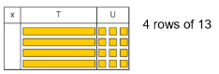  Move on to place value counters to show how we are finding groups of a number. We are multiplying by 4 so we need 4 rows.  Fill each row with 126.  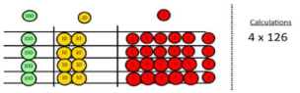 | Children can represent the work they have done with place value counters or Base 10 in a way that they understand.  They can draw the counters or Base 10, using colours to show different amounts or just use circles in the different columns to show their thinking as shown below.  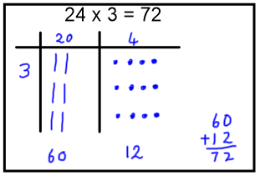 | Start with multiplying by one digit numbers and showing the clear addition alongside the grid.  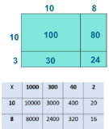  Moving forward, multiply by a 2 digit number showing the different rows within the grid method.
    X | 7
    30 | 210
    5 | 35
  CONCRETE | PICTORAL | ABSTRACT
  With place value counters (children need this stage, initially, to understand how the column method works)  6 x 23  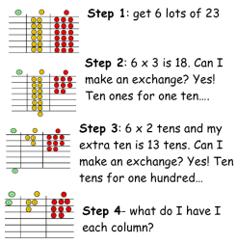 | 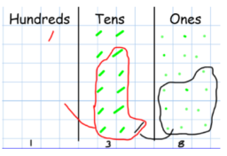  Children to represent the counters/base 10, pictorially e.g. the image below. | The aim is to get to the formal method but the children need to understand how it works.  Start with long multiplication, reminding the children about lining up their numbers clearly in columns.  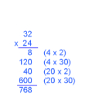  If it helps, children can write out what they are solving next to their answer.  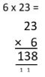  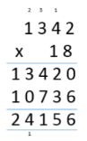  This moves to the more compact method.
